**Information System Management Lab**

**BCOM 307**

**Assignment #7**

***Submitted by:***

**Name:** YASH JAIN

**Enrollment No:** 03914788818

**Semester:** B.Com(H) 5th Semester

**Class:** B.COM(H)

**Section:** B.Com 5A

**Date of Submission:** 25/09/2021

***Submitted to:***

**Praveen Kumar Singh**

**Assistant Professor, MAIMS**



**Department of Commerce**

**Maharaja Agrasen Institute of Management Studies**

**Affiliated to Guru Gobind Singh Indraprastha University, Delhi**

**Sector -22, Rohini, Delhi -110086, India; www.maims.ac.in**

Maharaja Agrasen Institute of Management Studies

Affiliated to GGS IP University; Recognized u/s 2(f) of UGC Recognized by Bar Council ofIndia; ISO 9001: 2015

Certified Institution Sector 22, Rohini, Delhi -110086, India; [www.maims.ac.in](http://www.maims.ac.in/)

Department of Commerce

Academic Year: 2020-21

Semester: Vth

# Assignment No.7

# Unit No:

**Course/Subject Code:** BCOM 307 **Subject Title: Information System Management Lab**

# Issue Date: Last Date of Submission:

**Instructions for Students:**

# All Questions are Compulsory.

1. The student should attach proper cover page for each assignment clearly mentioning the Assignment No.
2. Each assignment should be prepared by the student individually with proper explaination and screenshots.
3. A4 size ruled sheets should be used for the assignment.
4. Assignment pages should be serially numbered at the bottom of page.

***During online education mode, upload scanned copy of the complete assignment including cover page latest by due date.***

|  |  |  |
| --- | --- | --- |
| **Question No.** | **Question** | **CO No.** |
| 1 | Create the table departments using the following the following columns and insert any 4 values in the table:   1. Dept_No INT (make this as primary key) 2. Dept_Name VARCHAR(20), CHECK that the department name should among the following: 3. Sales 4. Marketing 5. IT 6. Accounting 7. Location VARCHAR(20), CHECK that the location should be among the following: 8. Delhi 9. Mumbai 10. Noida 11. Gurugram | **CO1** |
| 2 | Create a table Employees using the following columns and insert any 3 values in it:  •   1. Emp_No INT (make this as primary key), also CHECK that the Employee number should be between 1000 and 2000. 2. Emp_Name VARCHAR(20) 3. Designation VARCHAR(20), CHECK that the designation should be among the following: 4. Saleman 5. Analyst 6. Manager   **CO 1**   1. President 2. Hire_date DATE 3. Salary INT, CHECK that the salary should be >=1000 and <=5000. 4. Commission INT 5. Dept_No INT (make this as the foreign key with reference to the department table), CHECK that the dept_no should be among the following: 6. 10 7. 20 8. 30 9. 40 |

**ASSIGNMENT 7 - CHECK CONSTRAINT**

**Task 1 : Create the table departments using the following the following columns and insert any 4 values in the table:**

1. **Dept_No INT (make this as primary key)**
2. **Dept_Name VARCHAR(20), CHECK that the department name should among the following:**
3. **Sales**
4. **Marketing**
5. **IT**
6. **Accounting**
7. **Location VARCHAR(20), CHECK that the location should be among the following:**
8. **Delhi**
9. **Mumbai**
10. **Noida**
11. **Gurugram**

The following task is completed using the **‘create table’** command, along with the **‘primary key’** constraint, and the **‘check’** constraint, and the **‘or’** conditional operator. The check constraint allows input in a particular column of a table, only when certain declared conditions are met. The syntax for the ‘check’ constraint (to be defined in table definition) is :

column_name check(condition),

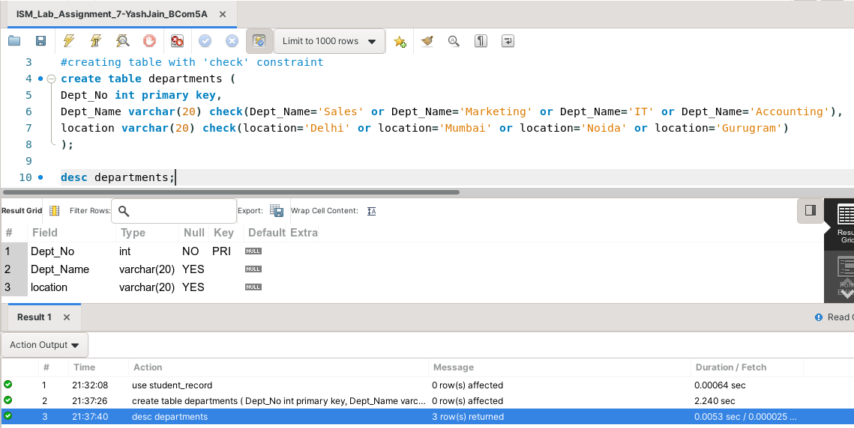

Now, if we enter any value in the columns defined via check constraint that does not satsify the conditions, then the query won’t be completed. This is depicted below.

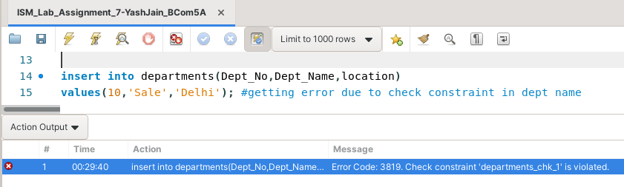

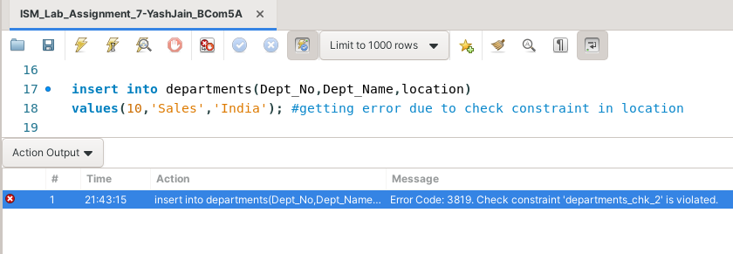

Now, queries in which all the conditions under the check constraint are satisfied will be executed without any trouble.

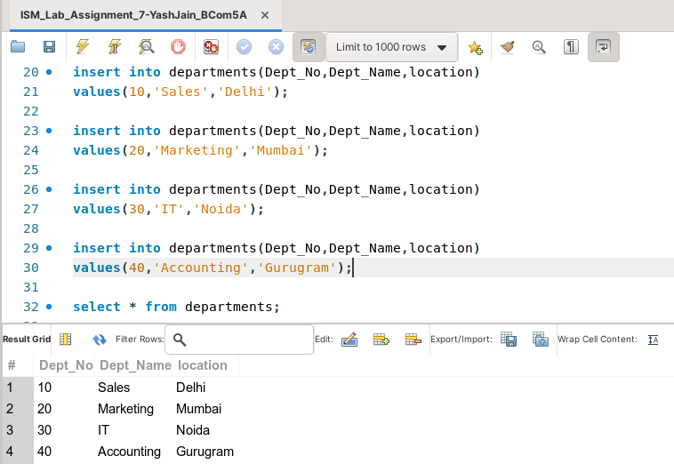

**Task 2: Create a table Employees using the following columns and insert any 3 values in it:**

**•**

1. **Emp_No INT (make this as primary key), also CHECK that the Employee number should be between 1000 and 2000.**
2. **Emp_Name VARCHAR(20)**
3. **Designation VARCHAR(20), CHECK that the designation should be among the following:**
4. **Saleman**
5. **Analyst**
6. **Manager**
7. **President**
8. **Hire_date DATE**
9. **Salary INT, CHECK that the salary should be >=1000 and <=5000.**
10. **Commission INT**
11. **Dept_No INT (make this as the foreign key with reference to the department table), CHECK that the dept_no should be among the following:**
12. **10**
13. **20**
14. **30**
15. **40**

The following task is completed using the **‘create table’** command, along with the **‘primary key’** constraint, and the **‘check’** constraint, and the **‘or’** and the **‘between’** conditional operator, that allows us to define a range of the values entered in a column.

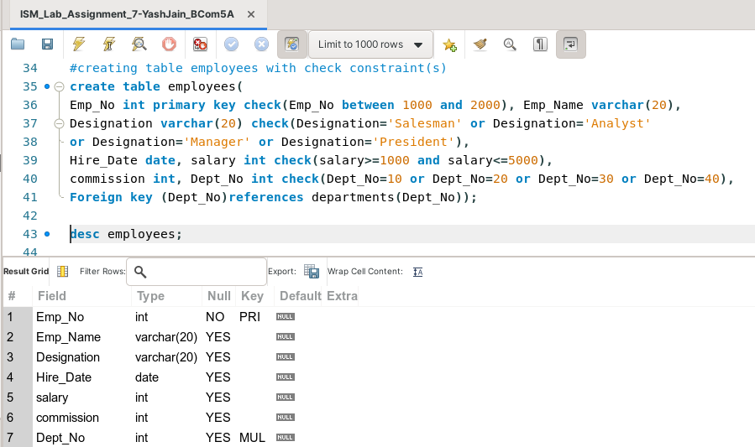

While inserting the values using **‘insert into’** command, it is important to realize that all the conditions in the check constraints of each column should be satisfied, to successfully execute a query.

Otherwise, it will show an error, displaying, ‘Check constraint error’. This is depicted here -

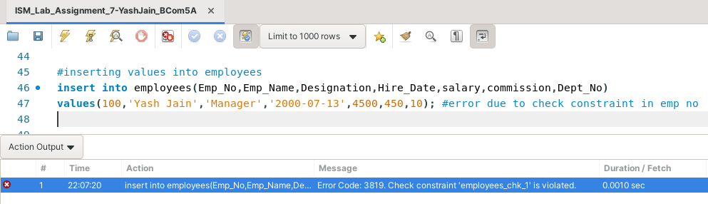

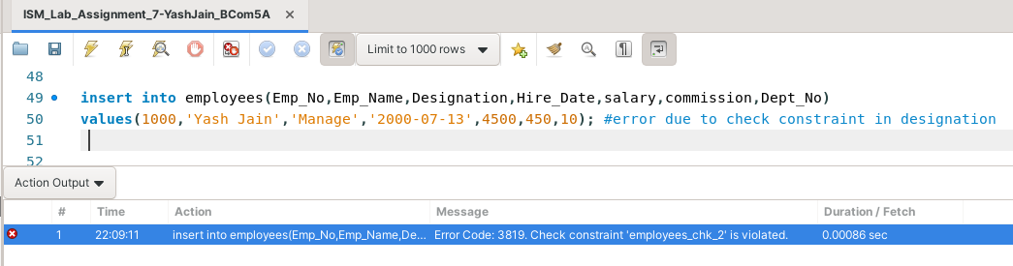

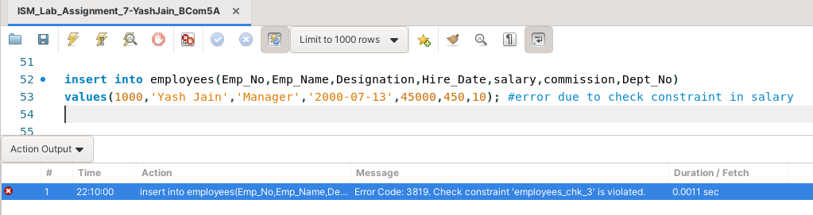

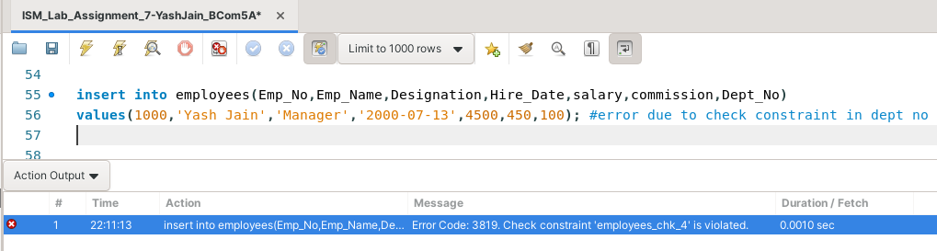

Now, to make our query successful, we need to enter values that satisfy the conditions of ‘check’ constraint of each and every column of the table. This is depicted below -

